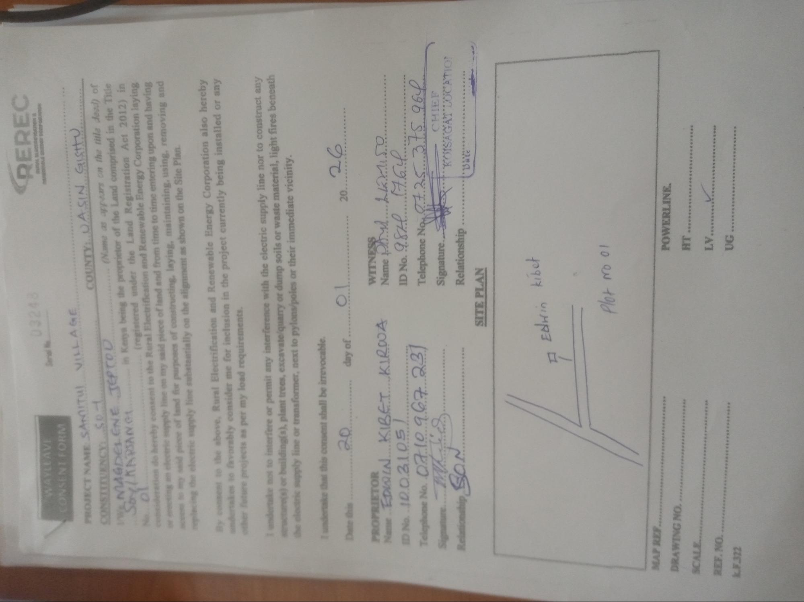
WAYLEAVE
CONSENT FORM
03248
PROJECT NAME SAMITU! VILLAGE
CONSTITUENCY: set
MAGDELENE JEPTOD
Soy/KARANG......
ol
considers
hereby consent
REREC
COUNTY: DASIN GISHTU
(Name as appears on the title dead) of
in Kenya being the proprietor of the Land comprised in the Title (registered under the Land Registration Act 2012) in the Rural Electrification and Renewable Energy Corporation laying supply line on my said piece of land and from time to time entering upon and having said piece of land for purposes of constructing, laying, maintaining, using, removing and aces to my said piece of supply line substantially on the alignment as shown on the Site Plan. replacing the elec
By
e
to the above, Rural Electrification and Renewable Energy Corporation also hereby undertakes to favorably consider me for inclusion in the project currently being installed or any other future projects as per my load requirements.
I undertake not to interfere or permit any interference with the electric supply line nor to construct any structure(s) or building(s), plant trees, excavate/quarry or dump soils or waste material, light fires beneath the electric supply line or transformer, next to pylons/poles or their immediate vicinity.
undertake that this consent shall be irrevocable.
Date this
20
day of.......1
20.
26
PROPRIETOR
Name EDWIN KIBET KIRWA
ID No. 10.0310S
Telephone No. 07.10.967 231
Signature Mh Wied
SON
Relationship So
WITNESS P
Name Se
ID No. 9.870 1766
Telephone No. 07.25 3.75 964
Signature.
Relationship
CHIEF
KOISAGAT LOCATION
Date
MAP REF.
DRAWING NO...
SCALE...
REF. NO....
k.F.322
SITE PLAN
A Edwin kibet
Plot No 01
POWERLINE.
HT...
LV....
UG....
****
*****
****

